★★☆☆☆
題組：基礎48題
題號：Uva300 - Maya Calendar
整理者：鄭紹雄
學號：ACS105103
使用語言:C++
解題日期：2018年8月11日
題目:
During his last sabbatical, professor M. A. Ya made a surprising discovery about the old Maya calendar.
From an old knotted message, professor discovered that the Maya civilization used a 365 day long year,called Haab, which had 19 months. Each of the first 18 months was 20 days long, and the names of the months were pop, no, zip, zotz, tzec, xul, yoxkin, mol, chen, yax, zac, ceh, mac, kankin, muan, pax, koyab, cumhu. Instead of having names, the days of the months were denoted by numbers starting from 0 to 19. The last month of Haab was called uayet and had 5 days denoted by numbers 0, 1, 2, 3, 4. The Maya believed that this month was unlucky, the court of justice was not in session, the trade stopped, people did not even sweep the floor.
For religious purposes, the Maya used another calendar in which the year was called Tzolkin (holly year). The year was divided into thirteen periods, each 20 days long. Each day was denoted by a pair consisting of a number and the name of the day. They used 20 names: imix, ik, akbal, kan, chicchan, cimi, manik, lamat, muluk, ok, chuen, eb, ben, ix, mem, cib, caban, eznab, canac, ahau and 13 numbers;
both in cycles.
Notice that each day has an unambiguous description. For example, at the beginning of the year the days were described as follows:
1 imix, 2 ik, 3 akbal, 4 kan, 5 chicchan, 6 cimi, 7 manik, 8 lamat, 9 muluk, 10 ok, 11 chuen, 12 eb, 13 ben, 1 ix, 2 mem, 3 cib, 4 caban, 5 eznab, 6 canac, 7 ahau, and again in the next period 8 imix, 9 ik, 10 akbal...
Years (both Haab and Tzolkin) were denoted by numbers 0, 1, ..., where the number 0 was the beginning of the world. Thus, the first day was:
Haab: 0. pop 0
Tzolkin: 1 imix 0
Help professor M. A. Ya and write a program for him to convert the dates from the Haab calendarto the Tzolkin calendar.
Input
The date in Haab is given in the following format:
NumberOfTheDay. Month Year
The first line of the input file contains the number of the input dates in the file. The next n lines
contain n dates in the Haab calendar format, each in separate line. The year is smaller then 5000.
Output
The date in Tzolkin should be in the following format:
Number NameOfTheDay Year
The first line of the output file contains the number of the output dates. In the next n lines, there
are dates in the Tzolkin calendar format, in the order corresponding to the input dates.
Sample Input
3
10. zac 0
0. pop 0
10. zac 1995
Sample Output
3
3 chuen 0
1 imix 0
9 cimi 2801
問題描述：
馬亞教授在研究馬雅文明的曆法上有了重大的發現，教授從繩結 上的訊息發現馬雅文明的一年有19個月共365天，這種曆制稱作"Haab"，前18個月每月有20天，由0開始編號到19，而第19個月只有5天，分別 為0, 1, 2, 3, 4，另外，每個月都有一個名字，依序為：pop, no, zip, zotz, tzec, xul, yoxkin, mol, chen, yax, zac, ceh, mac, kankin, muan, pax, koyab, cumhu, uayet。馬雅人相信第19個月是不幸的月份，所在在該月所有經濟活動都會停止，甚至會避免從事家務，連地都不掃了。
另外，基於宗教上 的理由，馬雅人還會使用另一種曆制，該曆制稱為"Tzolkin"，這種曆制的一年有260天，分為20種日子，每種日子13天，用13個整數與20個日 子的名稱來區分每一天，整數為1~13，20種日子的名稱為：imix, ik, akbal, kan, chicchan, cimi, manik, lamat, muluk, ok, chuen, eb, ben, ix, mem, cib, caban, eznab, canac, ahau。
注意，在Tzolkin這種曆制每一天的名稱不會衝突，例如一年前幾天的名稱如下所示：
1 imix, 2 ik, 3 akbal, 4 kan, 5 chicchan, 6 cimi, 7 manik, 8 lamat, 9 muluk, 10 ok, 11 chuen, 12 eb, 13 ben, 1 ix, 2 mem, 3 cib, 4 caban, 5 eznab, 6 canac, 7 ahau, 8 imix, 9 ik, 10 akbal...
每一年以整數表示，例如：0, 1, ...，由0開始表示，所以兩種歷制的第一天分別為：
Haab: 0. pop 0
Tzolkin: 1 imix 0
請寫一個程式幫助馬亞教授做日期的轉換，由Haab曆制轉到Tzolkin曆制。
Input
Haab的日期格式為：日 月 年
輸入的第一列為一個整數表示共有多少日期需要轉換，接下來有n列，每一列為一個以Haab曆制表示的日期，年份最多到5000。
Output
Tzolkin的日期格式為：數字 名稱 年
請在輸出的第一列顯示共有幾組日期，接下來的n列顯示對應的Tzolkin日期。
Sample Input | Sample Output
3  10. zac 0  0. pop 0  10. zac 1995 | 3  3 chuen 0  1 imix 0  9 cimi 2801
解法：
這是屬於比較有變化的月曆轉換題目，在於Tzolkin的月曆比較複雜
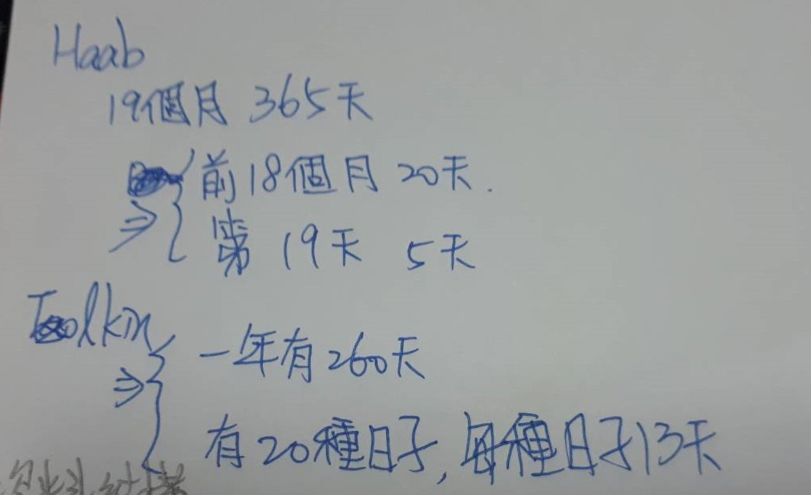
20種日子的名稱為：imix, ik, akbal, kan, chicchan, cimi, manik, lamat, muluk, ok, chuen, eb, ben, ix, mem, cib, caban, eznab, canac, ahau。
一年的前二十三天長這樣:
1 imix, 2 ik, 3 akbal, 4 kan, 5 chicchan, 6 cimi, 7 manik, 8 lamat, 9 muluk, 10 ok, 11 chuen, 12 eb, 13 ben, 1 ix, 2 mem, 3 cib, 4 caban, 5 eznab, 6 canac, 7 ahau, 8 imix, 9 ik, 10 akbal...
跟在相同日子前的數字不會變
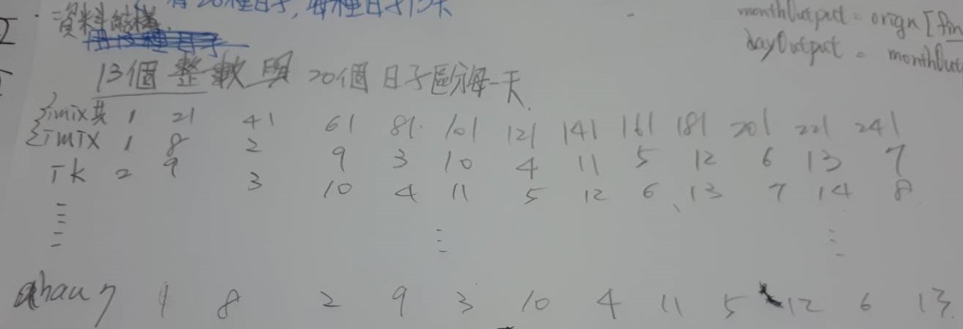
不過轉換日期的一個大原則就是變成總日子再來分
就可以解出題目了
解法範例：
資料結構:
int find(string,string); <=找出Habb對應的月份
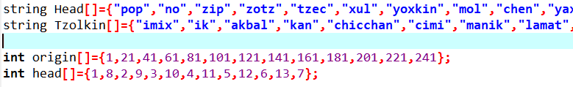
int findHoliday(int); <=找出總日期最近的imix的位置
int convert(string); <=string轉成int
將日期的名稱記下來，也將imix的位置記下來
演算法:
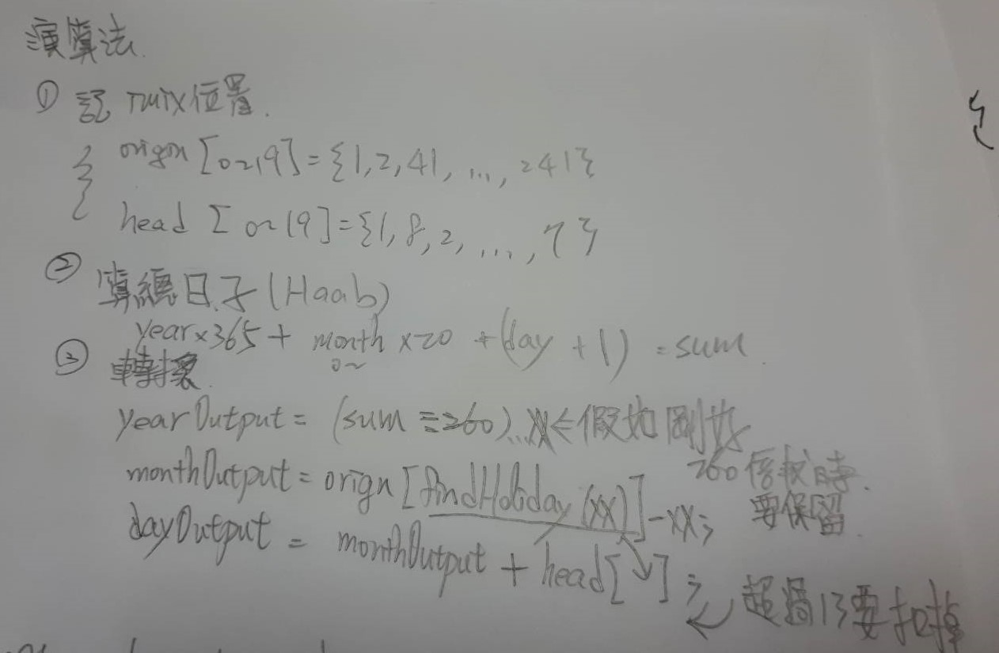
- 我們先把imix總日數先記住，要定義出是哪個日子只要算出跟imix的差值就可以找出來了
- 將Habb的日子轉成sum
- 使用sum去分成year、month、day
Year = 超過260會變成一年，等於260不能跳年(日子是1~260天)
Month=使用findHoliday找出最近的imix的日子，剩餘的日子-imix最接近的日子求出差額，就可以知道是哪個日子
Day=Month(差額)加上離該月最近的imix的頭就是該日子的頭

討論：
//1.要注意兩個月法的第一天不一樣
Haab: 0. pop 0
Tzolkin: 1 imix 0
//2.再取值的時候要注意陣列的大小，不要取超過會導致錯誤
//3.使用資料結構可以省下很多時間也可以讓概念更清楚
程式:
#include <iostream>
#include <sstream>
#include <cstring>

using namespace std;

int find(string,string);
int findHoliday(int);
int convert(string);

string Head[]={"pop","no","zip","zotz","tzec","xul","yoxkin","mol","chen","yax","zac","ceh","mac","kankin","muan","pax","koyab","cumhu","uayet"};
string Tzolkin[]={"imix","ik","akbal","kan","chicchan","cimi","manik","lamat","muluk","ok","chuen","eb","ben","ix","mem","cib","caban","eznab","canac","ahau"};

int origin[]={1,21,41,61,81,101,121,141,161,181,201,221,241};
int head[]={1,8,2,9,3,10,4,11,5,12,6,13,7};

int main(){

int nam;
cin>>nam;
cin.get();
cout<<nam<<endl;
while(nam--){
string allword;
getline(cin,allword);
string dayString,monthString,yearString,nouse;
stringstream ss(allword);
getline(ss,dayString,'.');
getline(ss,nouse,' ');
getline(ss,monthString,' ');
getline(ss,yearString,' ');

int day =convert(dayString);
int year=convert(yearString);
int month =find("Head",monthString);

int sum = year*365+month*20+day+1;

int outYear=0;
while(sum>260){
sum-=260;
outYear++;
}
int re = sum;

int outMonth =re-origin[findHoliday(re)];
int outDay = outMonth+head[findHoliday(re)];

while(outDay>13){
outDay-=13;
}

cout<<outDay<<" "<<Tzolkin[outMonth]<<" "<<outYear<<endl;
}

}
int convert(string str){
int integer;
stringstream ss;
ss<<str;
ss>>integer;

return integer;
}
int find(string kind,string name){
if(kind=="Head"){
for(int i =0 ;i<19;i++){
if(Head[i]==name){
return i;
}
}
}
return -2;
}
int findHoliday(int sumDay){
for(int i = 0;i<13;i++){
if(sumDay<origin[i]){
return i-1;
}
}
return 12;
}

